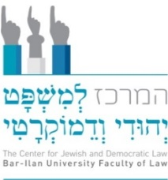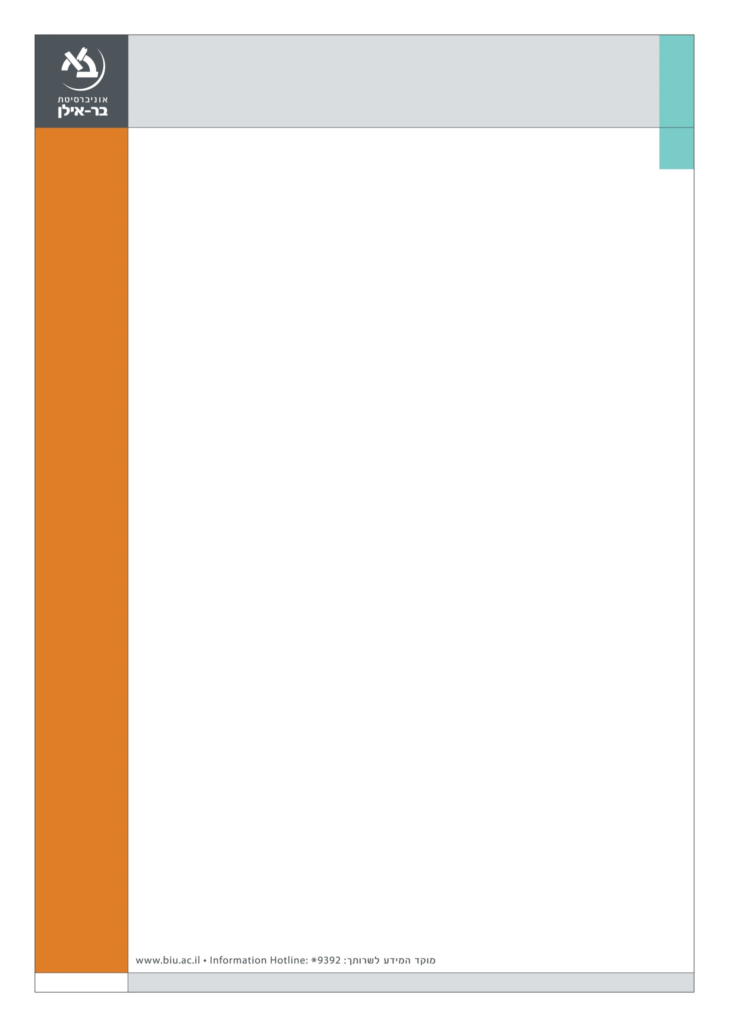

**The Faculty of Law**

**The Center for Jewish and Democratic Law**

**Invites the public to celebrate the launching of the book**

**“Trauma’s Omen: Israeli Studies in Identity, Memory and Representation”**

**Published by the Faculty of Law, Bar- Ilan University and Hakibbutz Hameuchad Publishing House**

**With the Support of Sir Mick Davis**

**Tuesday June 21st at 17:00**

**The Faculty of Law Building (305) Hall 11, ground floor**

**17:30-17:45 Gathering and light refreshment**

**17:45-18:15**  **Opening Session: On Trauma and Dialogue in a Jewish and Democratic State**

**Dean Prof. Shahar Lifshitz** and Head of The center for Jewish and Democratic Law, Bar-Ilan University Book Editors:

**Prof. Michal Alberstein**, Faculty of Law, Bar-Ilan University

**Prof. Nadav Davidovitch**, Head of Department of Health Systems Management, Ben Gurion University

**Dr. Rakefet Zalashik**, School of Social and Political Sciences, University of Edinburgh

**19:15-18:15 Trauma’s Omen: Israeli Studies in Identity, Memory and Representation**

**Dr. Keren Peleg-Friedman,** Academic Studies College of Management, *Trauma on The Couch: Anthropology in a folding chair beside it*

**Yoav Horesh,** artist and photographer, Visual Communication department Holon Institute for Technology, *Aftermath: (2002-2005) Suicide Bombing sites after the event*

**Hadas Ziv,** Director of Public Outreach, Physicians for Human Rights, *A Historically Persecuted Presence – What's Between the Yemenite Children and Depo-Provera?*

**ן**