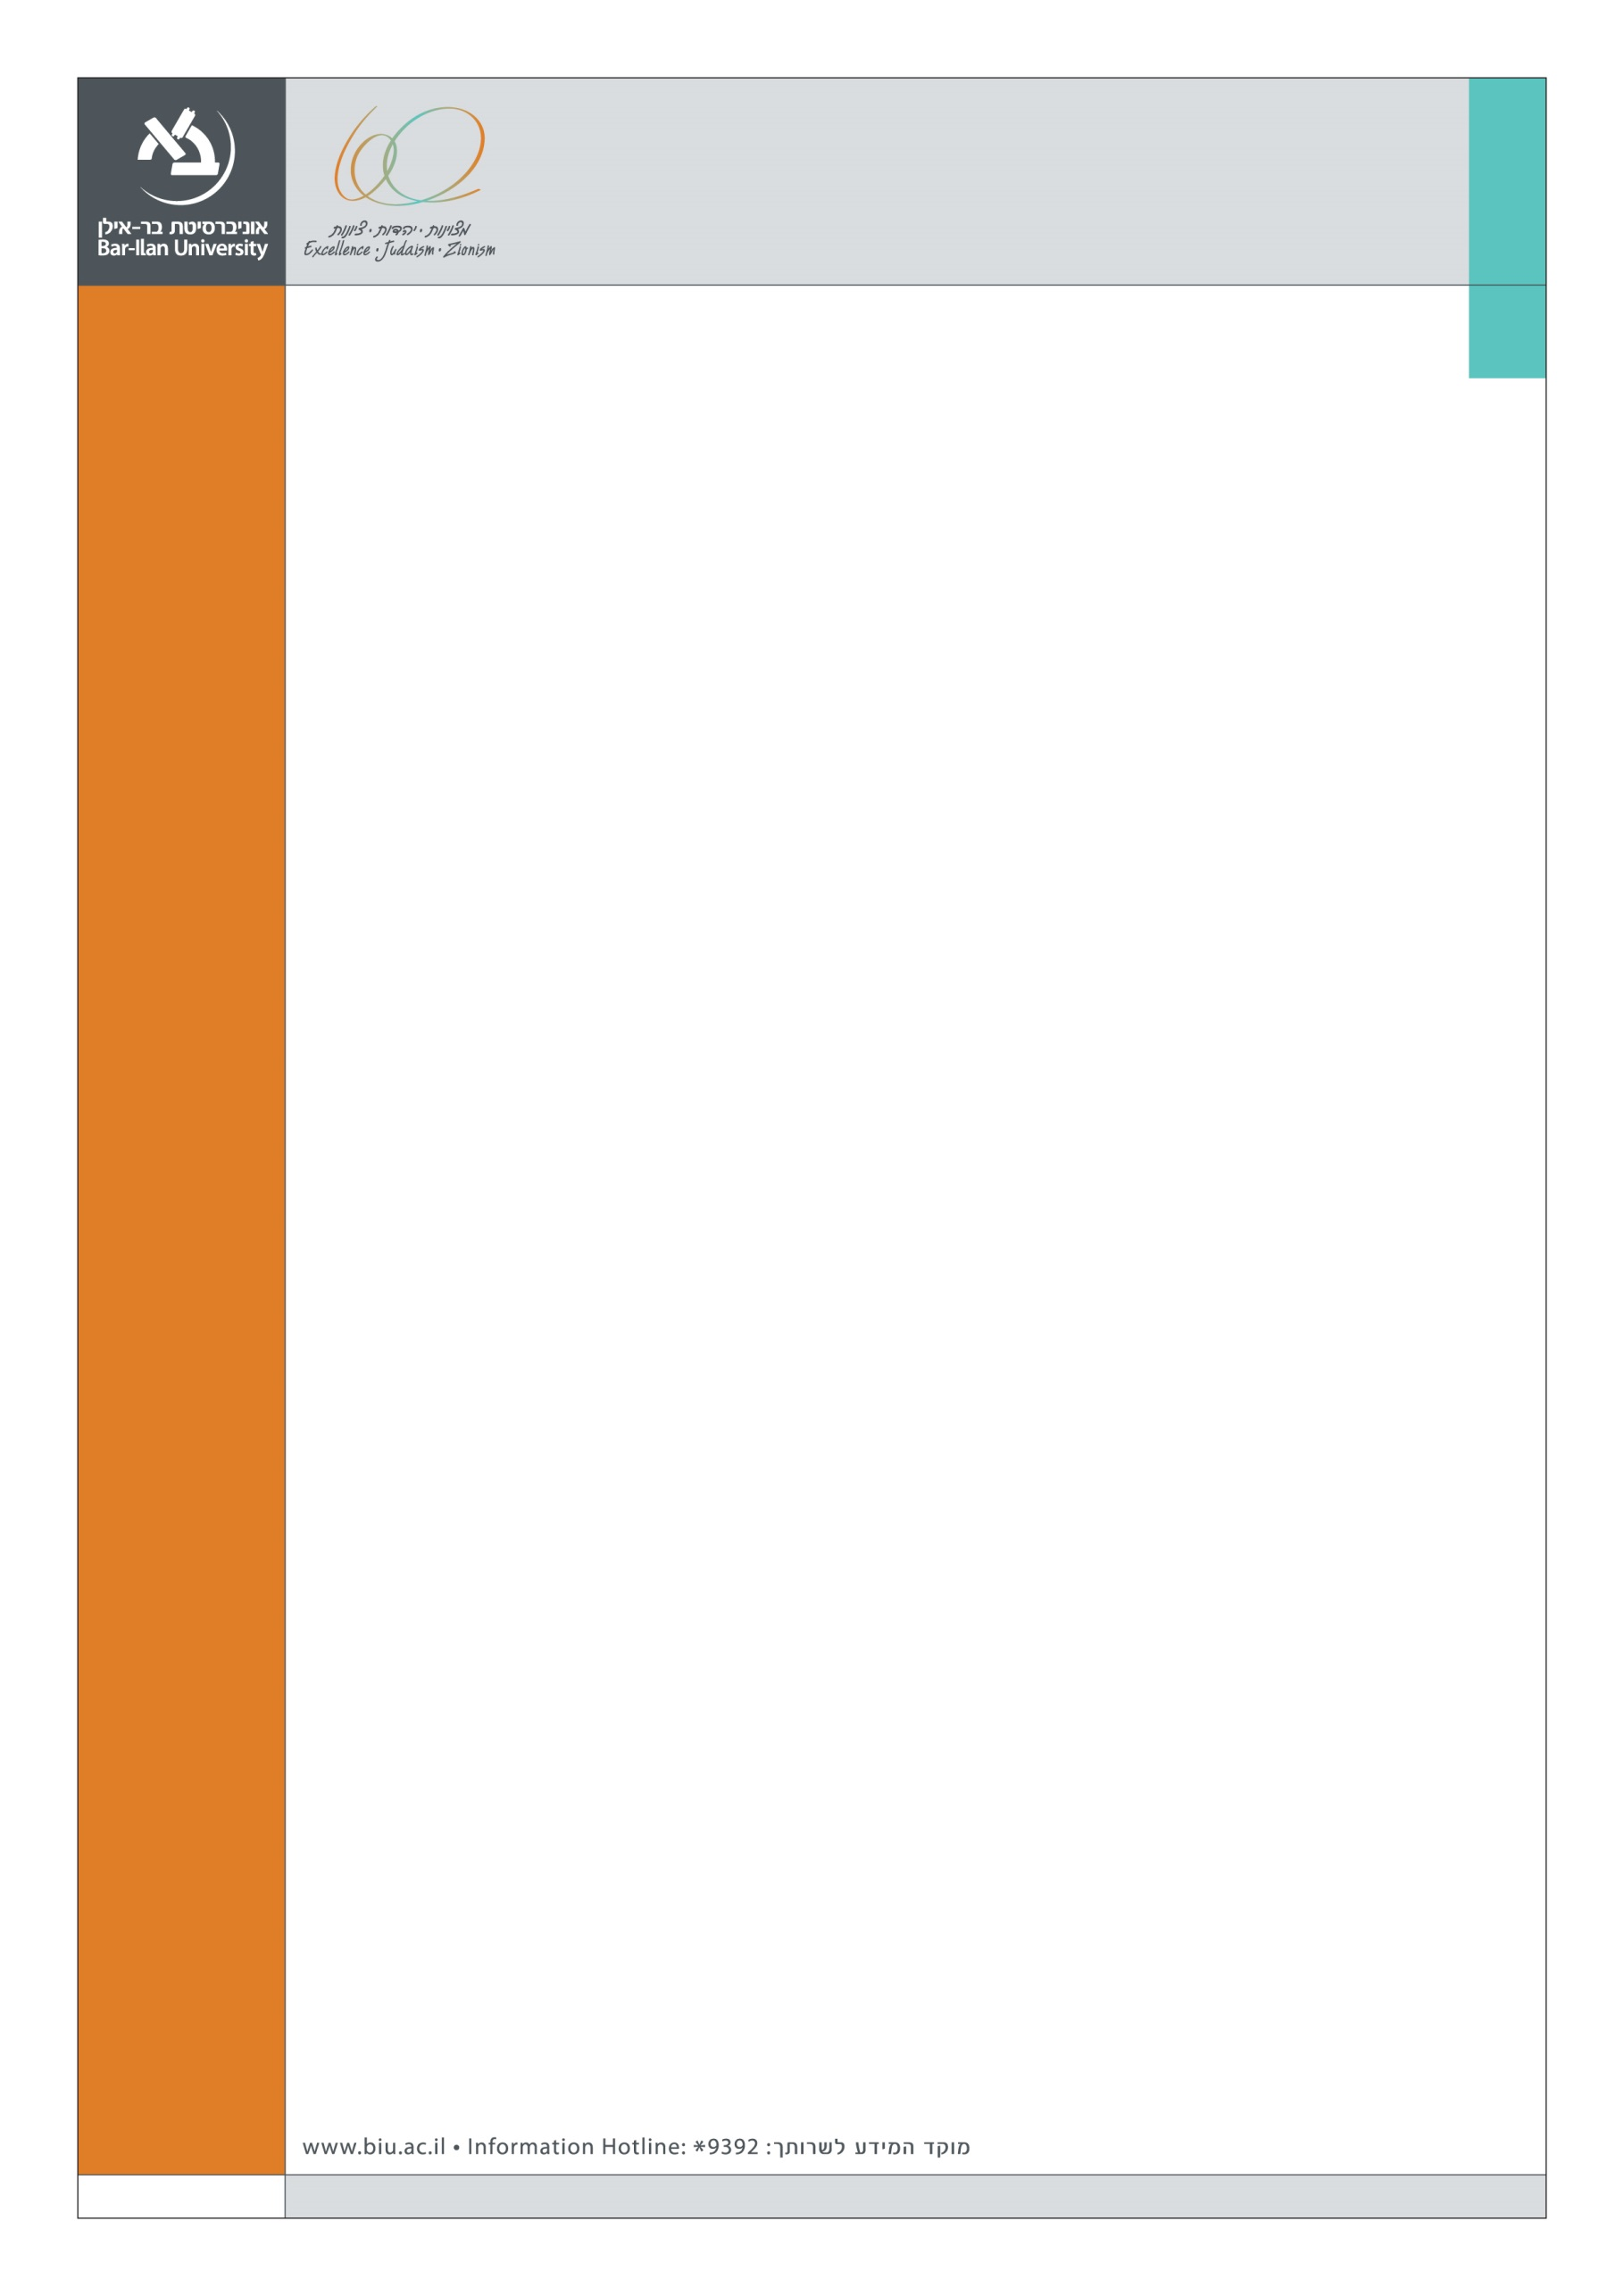

The Faculty of Law
Symposium on the work of Douglas Husak
December 17, 2014
The Maurice Benin Faculty of Law Building 306, Hall 200, 2nd floor

 | Gathering | 10:00
 | Workshop: Theory of the General Part of Criminal Law  Moderator: Arnold Enker, Bar-Ilan University | 10:30-14:30
 | Session I: Complicity  Commentator: Hadar Dancig-Rosenberg, Bar-Ilan University | 10:30-11:15
 | Session II: Mens Rea  Commentators: Shachar Eldar, Ono Academic College  Arnold Enker, Bar-Ilan University | 11:15-12:15
 | Lunch | 12:15-12:45
 | Session III: De Minimis  Commentator: Miriam Gur-Arye, Hebrew University of Jerusalem | 12:45-13:30
 | Session IV: Ignorance of Law  Commentator: Hanoch Sheinman, Bar-Ilan University | 13:30-14:15
 | Coffee Break | 14:15-14:30
 | Keynote Address  Douglas Husak, Rutgers University  Criminalization | 14:30-16:00
Please RSVP at: events.law@mail.biu.ac.il
Conference organizer: Hadar Dancig-Rosenberg

